**Jahangirnagar University**

**Department of Computer Science & Engineering**



**Course Code**: CSE-406

**Course Title**: Computer Networking Laboratory

**Submitted by**:

**Name**: Md. Shamim Imtiaz

**Roll No**: 47

**Date of Submission**: 19th December, 2019

**Experiment No: 09**

**Experiment Name:** Implementation of Mail Server.

**Objective:**

In this experiment we will configure routers in between some networks to connect to further network via routing table where network and hop will be mentioned. When sending a packet this routers will recognize which hop to jump to send a packet. In this lab we will try to send the data packet through routers and set the static connections with command line prompt. Here we used three routers and generic pcs. We also added two extra Ethernet with each of the router so that we connect them each other and they will find the shortest path to send the packets.

**Description:**

We used cisco packet tracer for simulation. Several computer devices are connected through the routers and different IP addresses were assigned to them. Then a packet is sent through them to check the characteristics of routers we created a hop table to access networks that are far from the routers to pass the packets.

**Router:**

Routers are small electronic devices that join multiple computer networks together using either wired or wireless connections. In technical terms, a router is a Layer 3 network gate way device, meaning that it connects two or more networks and that the router operates at the network layer of the OSI model.

**POP Protocol**: POP is short for post office protocol a protocol used to retrieve e-mail from a mail server. Most e-mail applications (sometimes called an e-mail client) use the POP protocol, although some can use the newer IMAP (Internet Message Access Protocol).There are two versions of POP**:(1)** The first, called POP2, became a standard in the mid-80's and requires SMTP(Simple Mail Transfer Protocol.) to send messages. (2)The newer version, POP3, can be used with or without SMTP.

**TCP Protocol**: TCP (Transmission Control Protocol) is a standard that defines how to establish and maintain a network conversation through which application programs can exchange data. TCP works with the Internet Protocol (IP), which defines how computers send packets of data to each other.

**Simulation:**

1. **Using one router:**

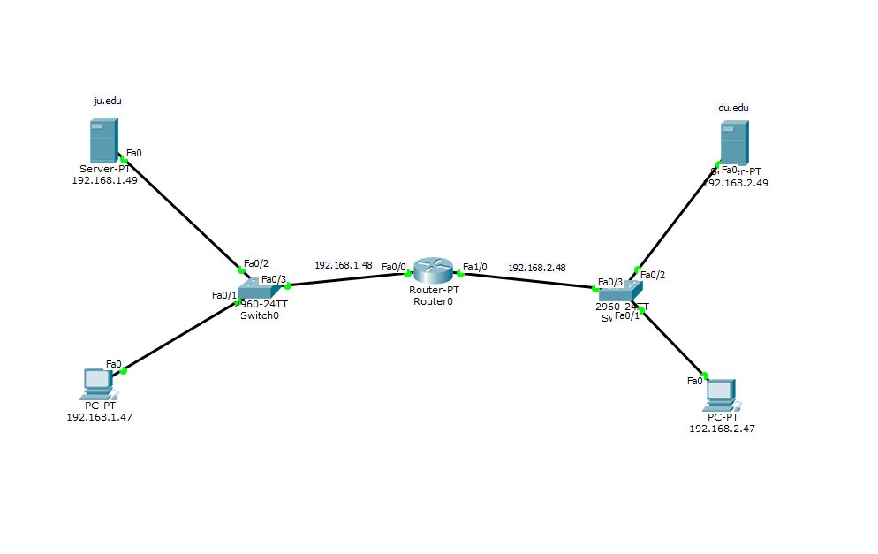

1. **Layer 3 switch and Router:**

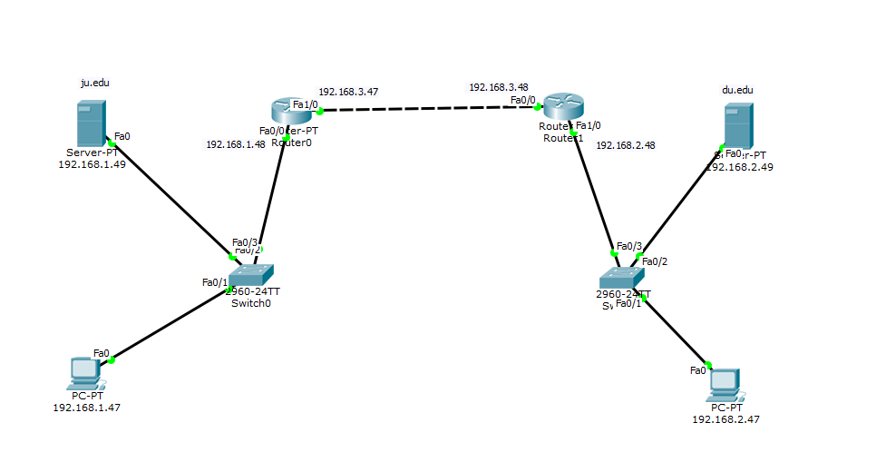

**Result:**

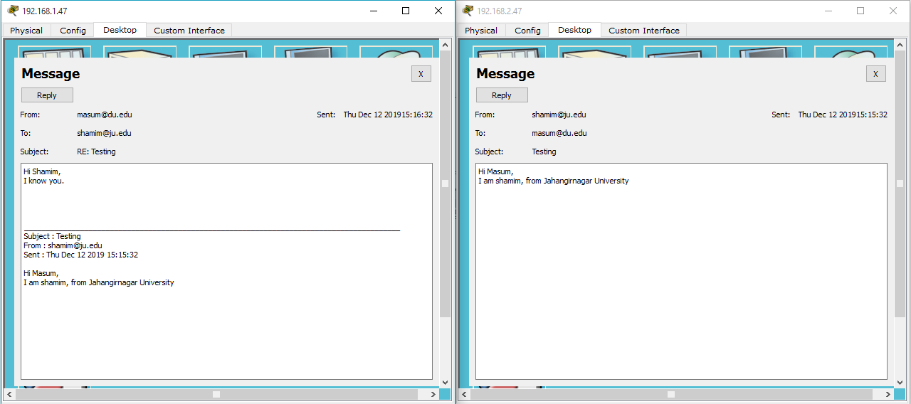

**Discussion:**

We can see that the Routers sends the packet the required path mentioned in the rout table. People tend to get benefit from a router for through a packet to a different network. A router is better for connecting different network. After using router we can easily use hub, switch, PC for any other connection and for any other communication.